SQL Subquery: Complete Guide
This guide provides a comprehensive explanation of SQL subqueries, covering their definition, types, execution flow, and practical applications in various SQL clauses.

What is a Subquery?
Definition: A subquery (or inner query) is a query nested inside another SQL query (the outer or main query).
Structure:
SELECT ... FROM ... WHERE ... (SELECT ... FROM ... WHERE ...)
Role: The subquery acts as a "supporter" to the main query, providing it with data.
Execution Flow (Non-Correlated):
- SQL first identifies and executes the subquery.
- The result of the subquery is an intermediate result set (a temporary table or value) stored in memory. This result is not sent to the user/output.
- The main query then uses this intermediate result to perform its operations (filtering, joining, etc.).
- The final result of the main query is sent to the user.
- Once the entire query execution is done, the intermediate result of the subquery is destroyed from memory.
Key Point: Intermediate results are local to the main query and cannot be accessed by other, external queries.

Why Are Subqueries Important?
Subqueries help in breaking down complex tasks into smaller, manageable, and logical steps, making queries:
- Easier to Write: You can build logic step-by-step.
- Easier to Understand and Read: Each subquery can represent a distinct logical step.
- Enabling Step-by-Step Analysis: They allow you to prepare data in stages, where the output of one step (subquery) becomes the input for the next (main query or another subquery).
- Reducing Complexity: Instead of a single, long, complex query, you have a flow of smaller, interconnected queries.

Types of Subqueries Based on Dependencies
This categorizes subqueries based on whether they rely on the main query for their execution.
Non-Correlated Subquery
Definition: A subquery that can run independently of the main query. It doesn't need any values from the outer query to execute.
Execution: Executed only once by the database engine. Its result is fully determined before the main query starts processing.
Characteristics:
- Simpler to write and read.
- Generally faster because they are executed only once.
- Used for static comparisons, where the subquery provides a fixed set of values or a single value to the main query.
- Can be executed on its own to see the intermediate results.
Correlated Subquery
Definition: A subquery that relies on values from the main query for each row it processes. It cannot run independently.
Execution: Executed multiple times (once for each row processed by the main query).
Process Flow:
- SQL starts executing the main query first, processing it row by row.
- For each row, the main query passes relevant information (e.g., a column value) to the subquery.
- The subquery then executes, using the value passed from the current row of the main query.
- Based on the subquery's result, the main query decides whether to include or exclude that specific row from its final output.
- This cycle repeats for every row in the main query's result set.
Characteristics:
- More complex to write and read.
- Potentially slower due to repeated execution for each row.
- Used for row-by-row comparisons or dynamic filtering based on values from the current row being processed by the main query.
- Cannot be executed on its own because it depends on values from the main query.

Types of Subqueries Based on Result Type
This categorizes subqueries based on the amount of data they return.
Scalar Subquery
- Definition: Returns only one single value (one row, one column).
- Example:
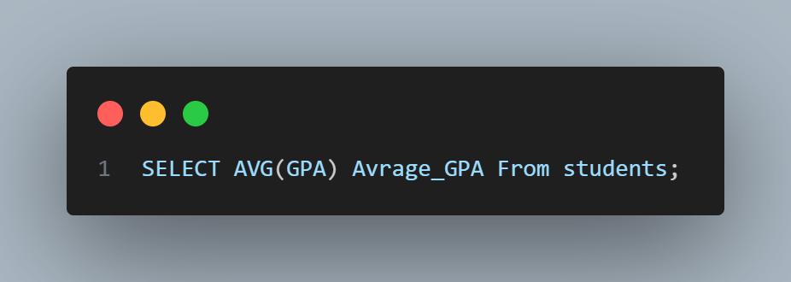
(returns a single average value like 38).
- Use Cases: Most commonly used in the SELECT clause (as a calculated column) and with WHERE clause comparison operators (e.g., =, >, <).
Row Subquery
- Definition: Returns multiple rows but only a single column (a list of values).
- Example:
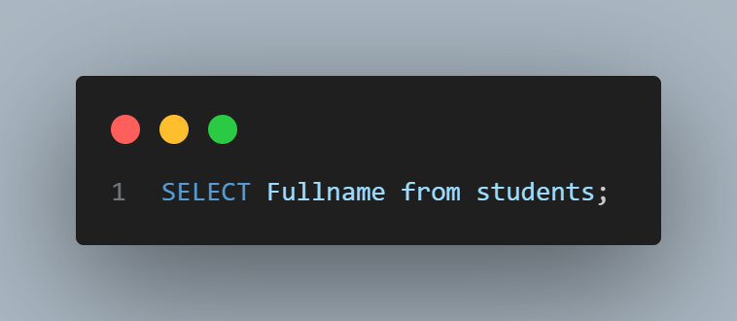
(returns a list of customer IDs).
- Use Cases: Primarily used with WHERE clause logical operators like IN, ANY, ALL.
Table Subquery
- Definition: Returns multiple rows and multiple columns, essentially acting as a temporary table.
- Example:
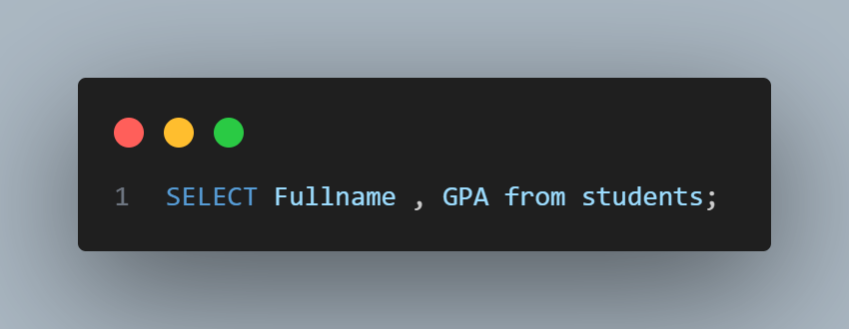
(returns a full result set).
- Use Cases: Most commonly used in the FROM clause of the main query.

Subquery Locations/Clauses
Subqueries can be placed in different parts of an SQL query, each serving a distinct purpose.

Subquery in the FROM Clause (Table Subquery)
Purpose: To create a temporary result set that acts as a table for the main query. This is useful for preparing data (e.g., aggregations, joins) before the main query processes it.
Syntax:
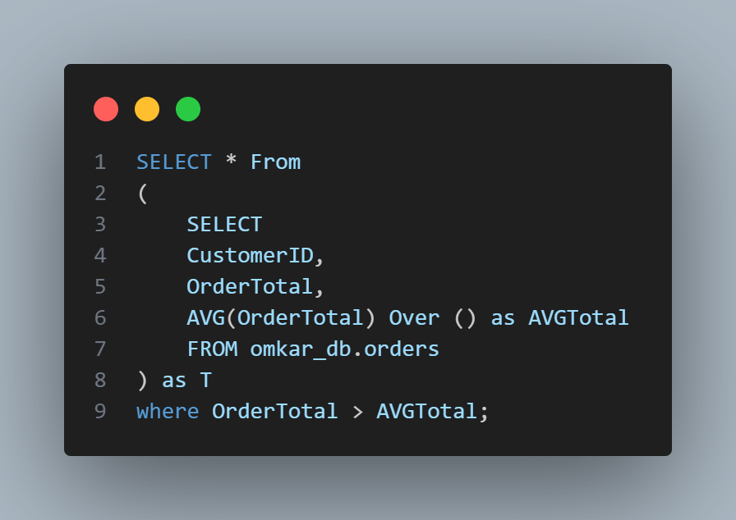
Examples:
Find Products with Price Higher Than Average:
Calculates average price for each product using a window function in the subquery.
The main query then filters this prepared data based on the average price.
Rank Customers by Total Sales:
Subquery calculates total_sales per customerID using GROUP BY.
Main query then applies a RANK() window function on this total_sales column.
Execution Flow: SQL first executes the entire subquery to form an intermediate result set, then the main query operates on this intermediate result as if it were a regular table.

Subquery in the SELECT Clause (Scalar Subquery)
Purpose: To aggregate data side-by-side with columns from the main query, often used to display a single aggregated value (like a total or average) for every row of the main query.
Syntax:
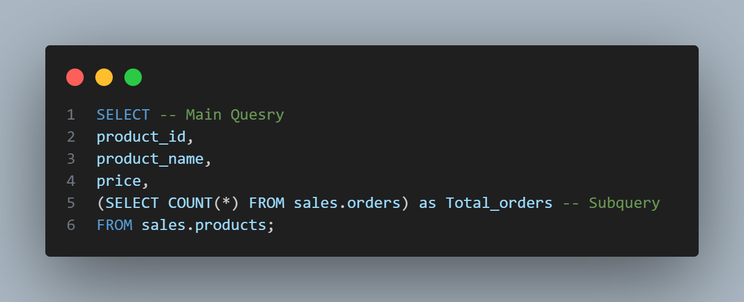
Rule: The subquery must be a scalar subquery (returns only one single value).
Example:
Show Product Details and Total Number of Orders:
Main Query: SELECT productID, product_name, price FROM sales.products
Subquery: SELECT COUNT(*) FROM sales.orders
Combined: Adds total orders count as a new column to each product row.
Execution Flow: SQL executes the scalar subquery first, obtains a single value, passes it to the main query, and the main query adds this value as a column to all its rows.

Subquery in the JOIN Clause
Purpose: To prepare data dynamically before joining, creating a temporary result set that can be joined with another table.
Syntax:
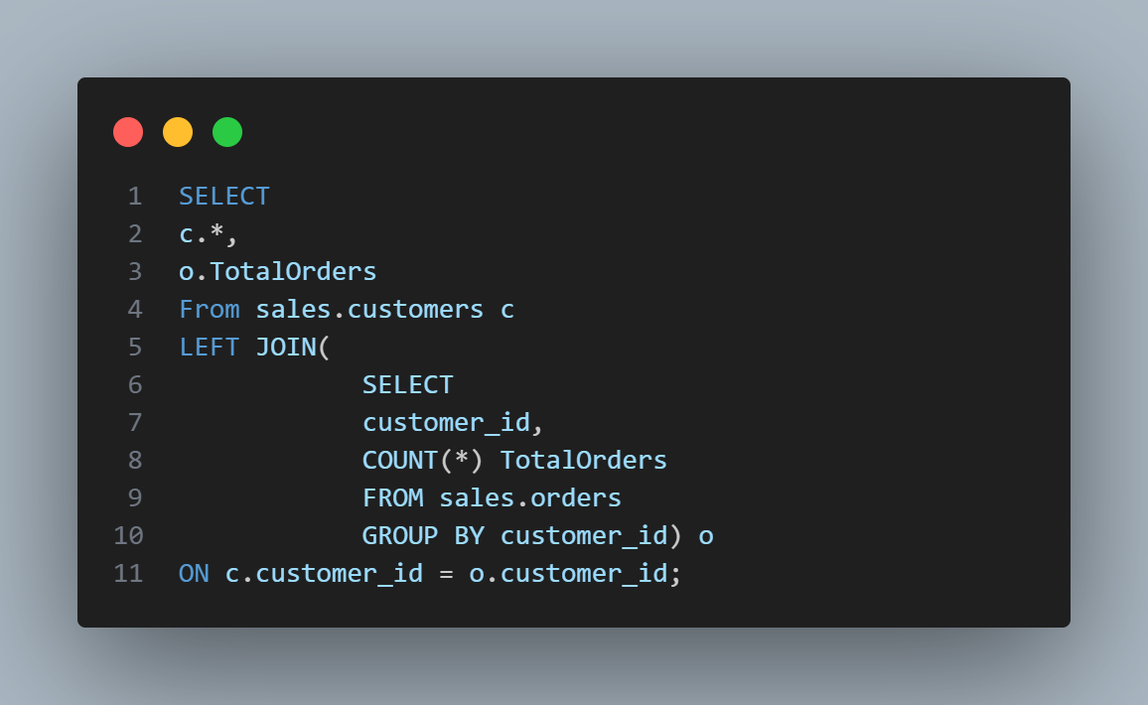
Example: Show Customer Details and Total Orders of Each Customer.
The subquery calculates total orders per customer using GROUP BY and joins it with the customer table to show total orders.
Benefit: Allows pre-processing or aggregating data before joining, making complex joins more manageable.

Subquery in the WHERE Clause
Purpose: To filter data in the main query based on complex logic or dynamic values provided by the subquery.
Can be used with two groups of operators: Comparison Operators and Logical/Subquery Operators.

Using with Comparison Operators
Operators: =, !=, >, <, >=, <=
Syntax:
WHERE column_name comparison_operator (subquery)
Rule: The subquery must be a scalar subquery (returns only one single value).
Example:
Products with Price Higher Than Average:
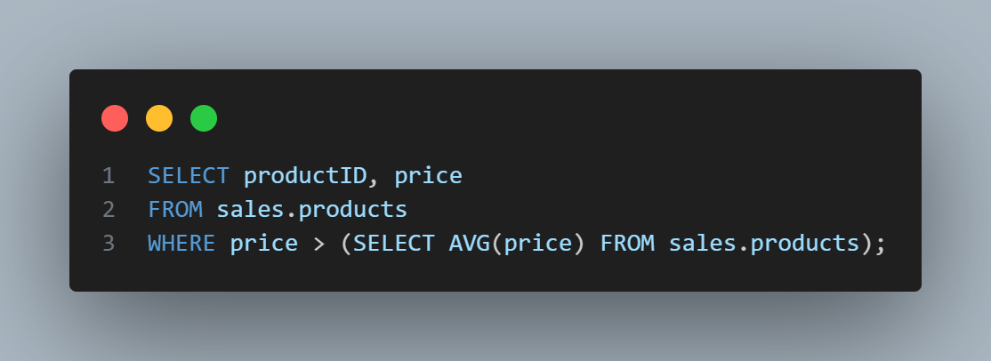
Execution Flow: SQL first executes the scalar subquery to get the average price, then uses this value for filtering.

Using with Logical/Subquery Operators
IN Operator
Purpose: To filter data based on whether a value matches any value from a list of multiple values.
Syntax:
WHERE column_name IN (subquery)
Rule: Subquery can return multiple rows but only one column.
Example:
Orders by Customers in Germany:
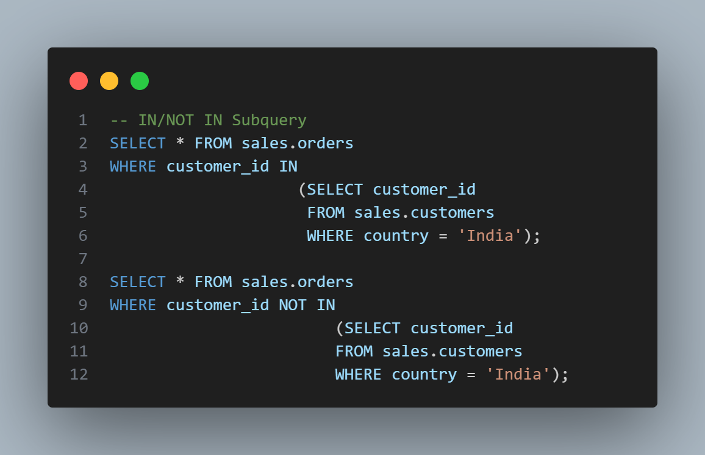
NOT IN: Used to find rows where the value does not exist in the subquery’s result.
Execution Flow: SQL executes the subquery first to generate the list of values, then filters rows based on membership.

ANY Operator
Purpose: Compares a value to any value in a list returned by the subquery using a comparison operator.
Syntax:
WHERE column_name comparison_operator ANY (subquery)
Example: Female employees whose salary is greater than any male employee’s salary:
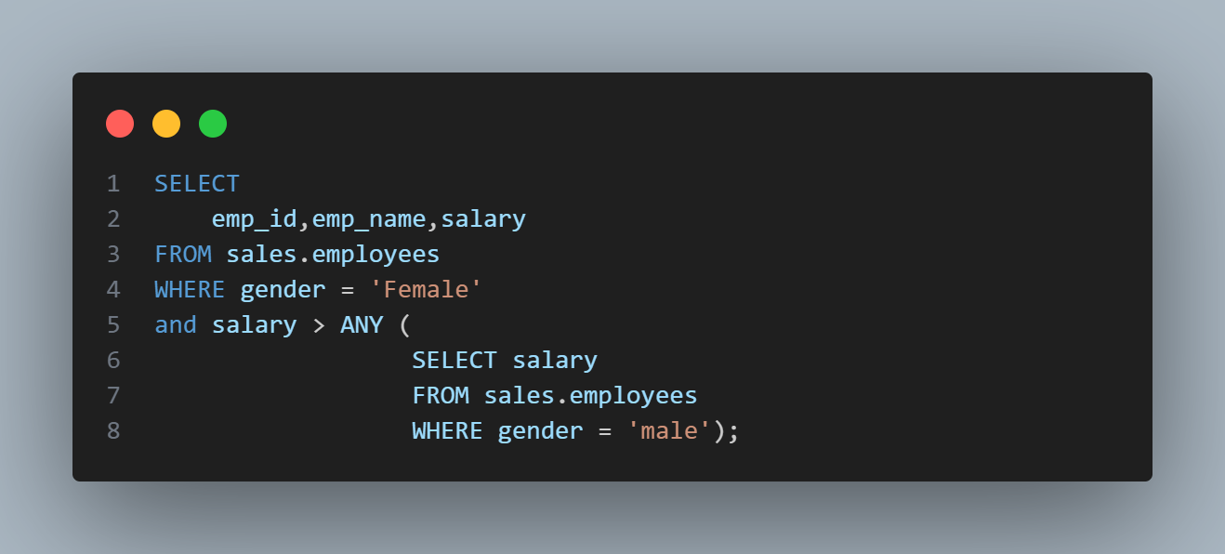

ALL Operator
Purpose: Compares a value to all values in a list returned by the subquery. Condition is true only if true for every value.
Syntax:
WHERE column_name comparison_operator ALL (subquery)
Example: Female employees whose salary is greater than all male employees’ salaries:
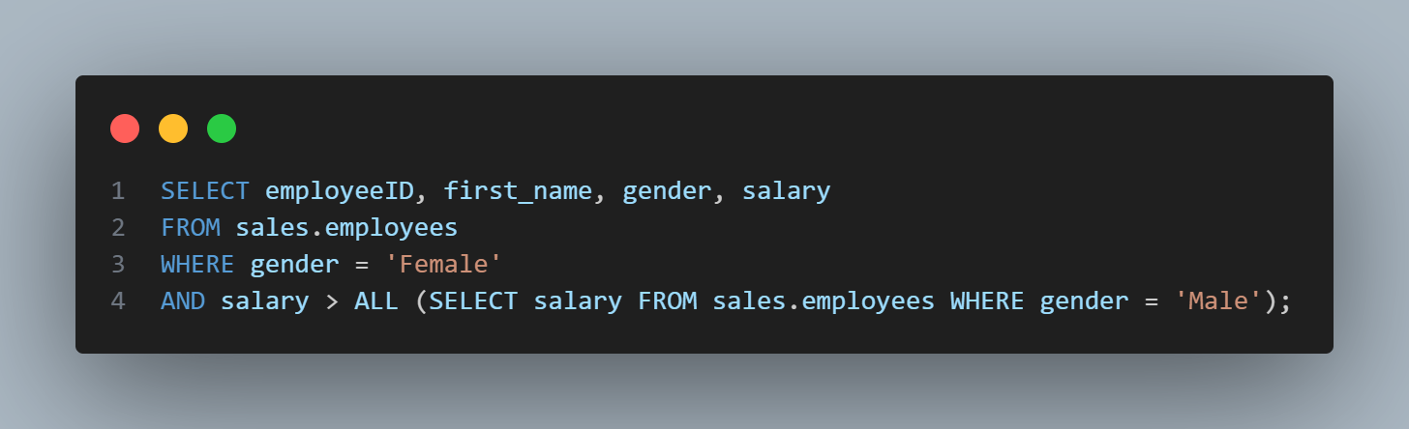

EXISTS Operator (Correlated Subquery)
Purpose: Checks for the existence of rows in the subquery’s result. Returns TRUE if the subquery returns any rows, FALSE otherwise.
Syntax:
WHERE EXISTS (SELECT 1 FROM table_name WHERE correlation_condition)
Example: Orders by Customers in Germany:
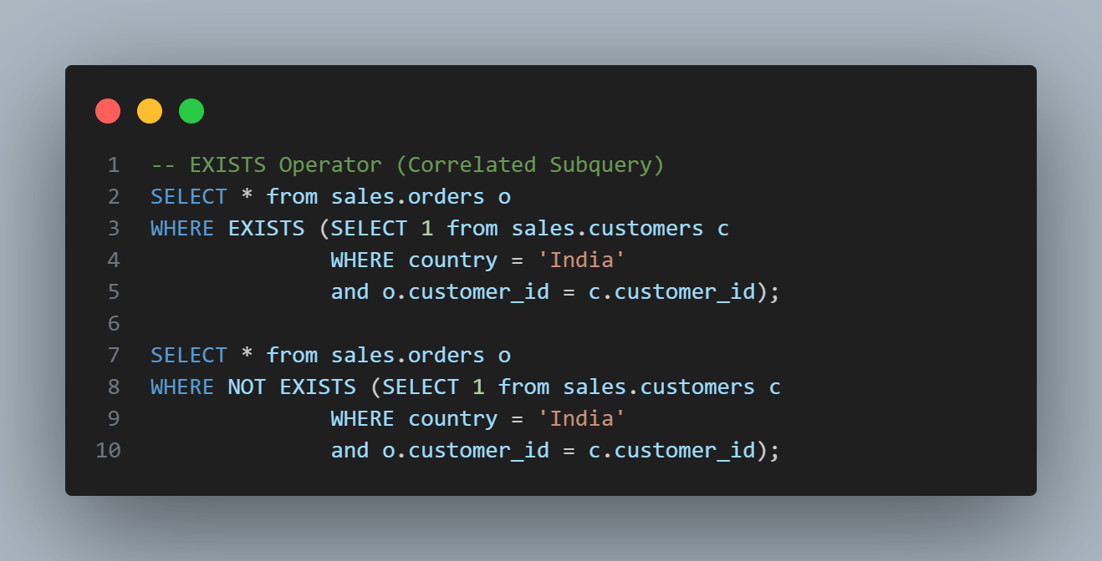
NOT EXISTS: Used to find rows where the subquery returns no results.
Execution Flow: SQL processes the main query row by row. For each row, the subquery executes using a value from that row. Based on whether the subquery returns any results, the main query decides to include or exclude that row.

